UAT Plan

for

Tilt Rush

Index

1. Scope 3

1.1. Objectives and business requirements 3

1.2. Scope 3

2. Testing team 4

3. Environmental requirements 5

3.1. Hardware requirements 5

3.2. Software requirements 5

4. Test Scripts 1

# Scope

## Objectives and business requirements

In this section, outline the business requirements. In other words:

* What are our goals? What are we hoping to accomplish with this project/feature?
* How will we measure success?

The goal is to have both a functioning sign-in page, and a functioning stats page, which then displays the name chosen in the sign-in page. This will be successful if the tester can load the homescreen, go to both pages and back, and can correctly use the content. All of this should also be saved through localstorage.

## Scope

In this section, outline the scope. This means:

* What is the pain point we’re trying to fix?
* What are we testing exactly, and what are we *not* testing?

We are trying to make the sign-in page and stats page work as intended. As the game has not yet been made, a temporary way to add stats will be added to the homescreen.

We are not making anything with the actual game or its mechanics as of yet.

## System Diagrams

In this section, paste any drawings or diagrams that help the UAT team understand the program being tested. With each drawing include a brief explanation of how the drawing represents the application or system being tested.

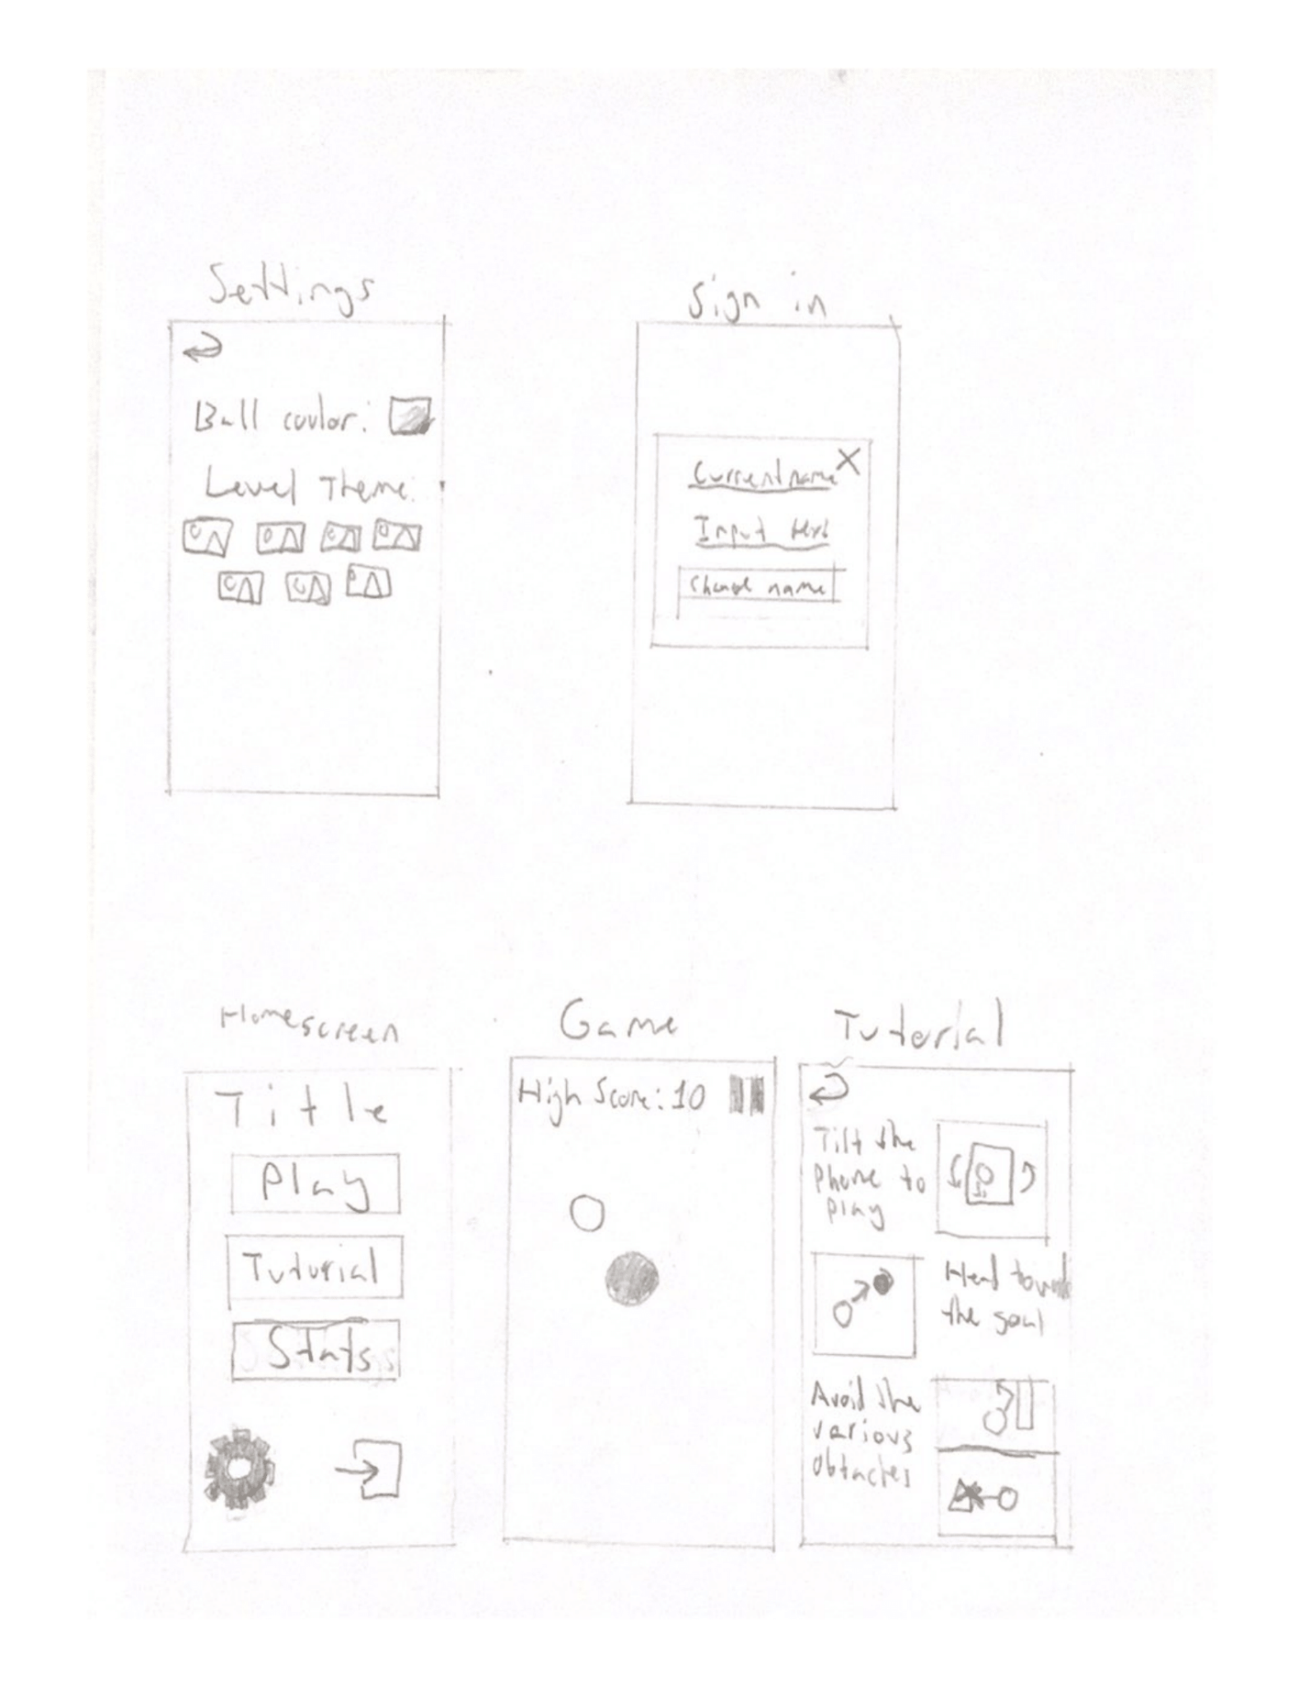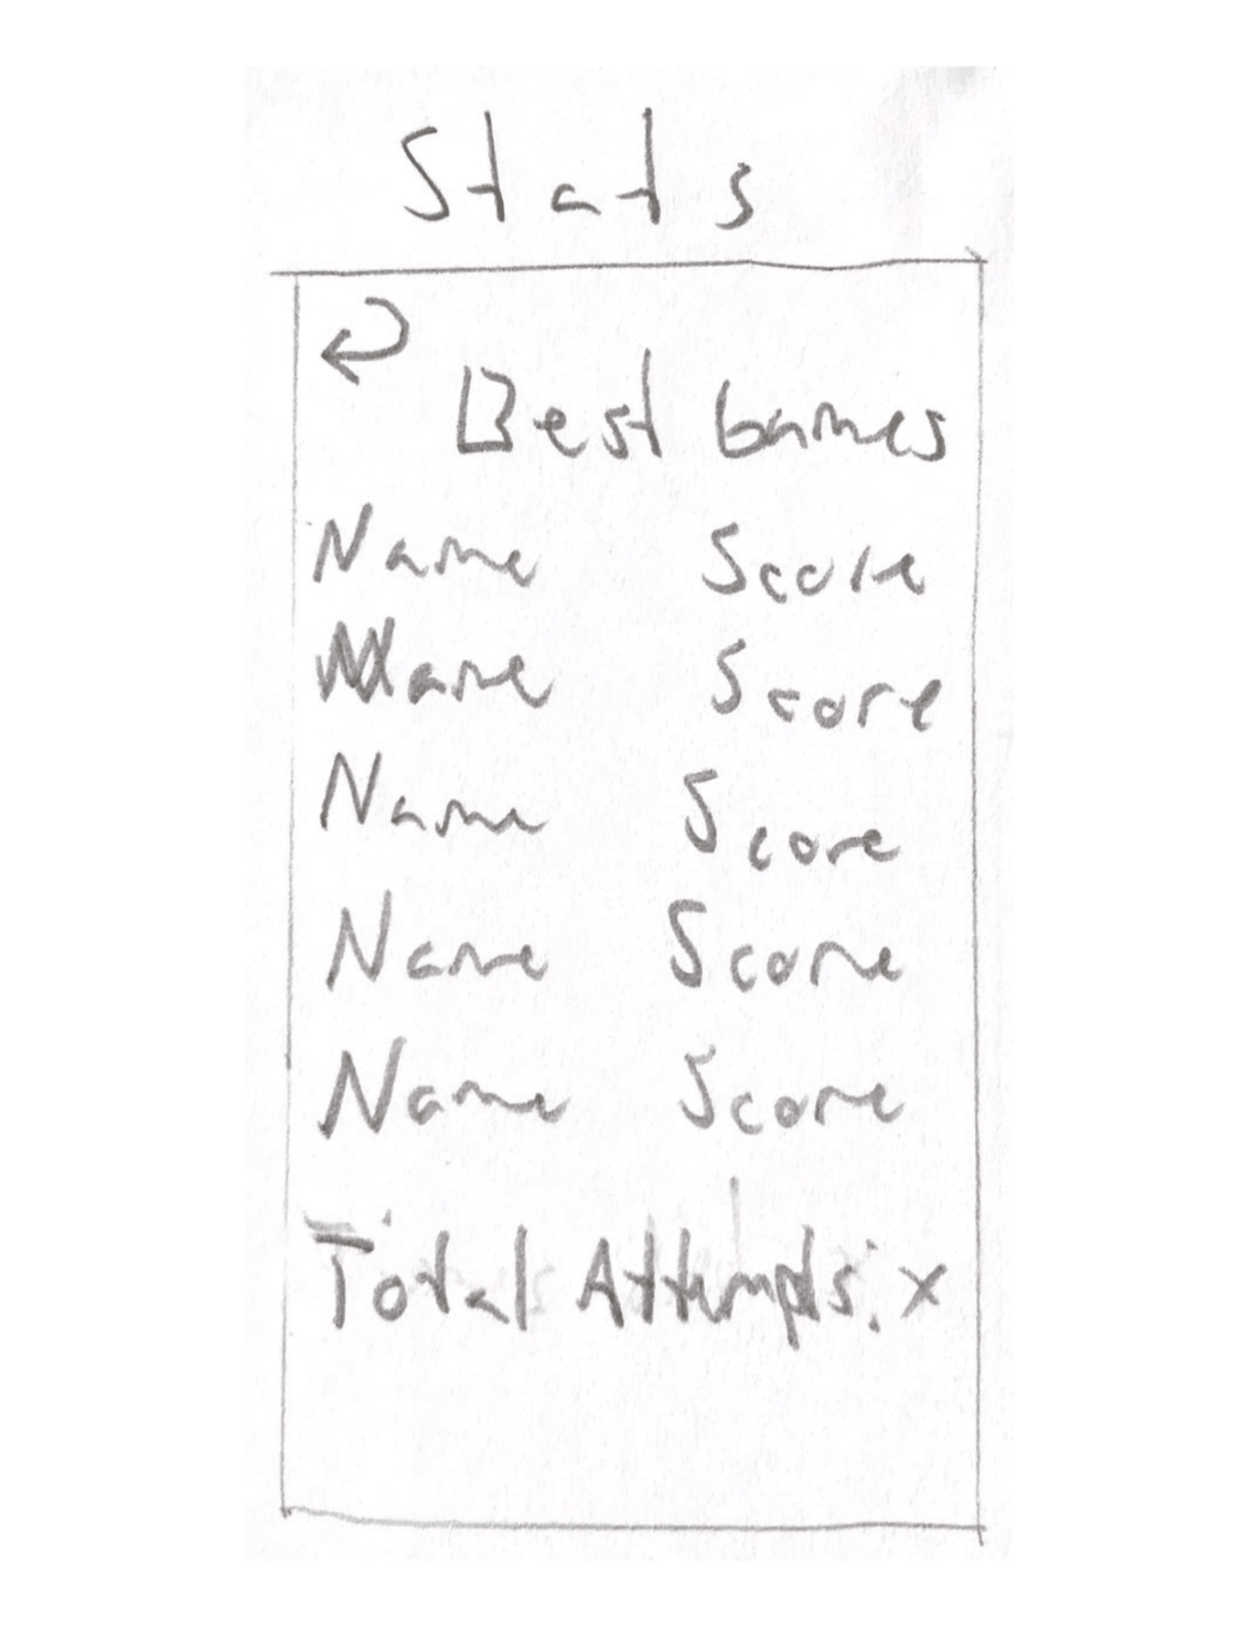

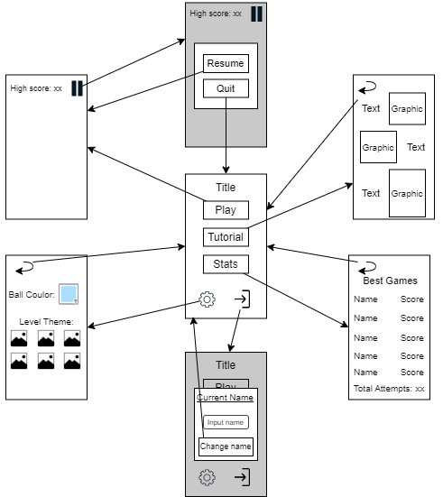

# Testing team

In this section, list out members of your QA team and what their roles will be during UAT.

Example:

| **Name** | **Responsibilities** |
| --- | --- |
| Theo Kiaris | Check sign-in page and stats page are working properly. Also check for proper local storage functionality. |
| Areesh Khan | Check sign-in page and stats page are working properly. Also check for proper local storage functionality. |

# Environmental requirements

## Hardware requirements

What hardware has the solution been designed for and should be tested on.

If that is the case, outline the minimal and recommended requirements so the QA team can verify that the software runs on the testers’ machines.

Phone with online capabilities.

## Software requirements

If any extra software or dependencies must be downloaded and installed, list them here.

* Google Chrome (or similar browser)

## Network requirements

Some software (design, video editing…) can be demanding on hardware specifications.

If that is the case, outline the minimal and recommended requirements so the QA team can verify that the software runs on the testers’ machines.

* Working internet connection

# Test Scripts

This section is more important than it seems—it is crucial that both the QA team and the testers know what features must be tested, especially if you’re testing a lot at once.

| **Test** | **Describe the feature being tested** | **Describe the user input or test data** | **Describe the pass criteria** |  |
| --- | --- | --- | --- | --- |
| 2.1 | Sign-in page | 1. Open app 2. Press sign-in button 3. Enter text into input box 4. Press “change name” button 5. Repeat previous two steps 6. Press “X” button | 1. Homescreen loads with required visuals (5 buttons, title), as well as temporary text input 2. Sign-in button and “X” button go to sign-in page and homescreen respectively 3. “Change name” button changes the displayed name | Tester name: Theo Kiaris   |  | PASS | | --- | --- | |  | FAIL |   Observations:  Tester name: Areesh Khan   |  | PASS | | --- | --- | |  | FAIL |   Observations: |
| 2.2 | Stats page | 1. Open app 2. Press stats button 3. Press back button | 1. Homescreen loads with required visuals (5 buttons, title), as well as temporary text input 2. Stats page loads | Tester name: Theo Kiaris   |  | PASS | | --- | --- | |  | FAIL |   Observations:  Tester name: Areesh Khan   |  | PASS | | --- | --- | |  | FAIL |   Observations: |
| 2.3 | Stats being saved | 1. Enter a positive integer into the temporary text input 2. Enter same the number, and then a different number into temporary text input 3. Change name 4. Enter new number into temporary text input 5. Enter 2 more numbers in, one of which is lower than all previous results | 1. All 5 displayed scores are the highest 5 scores inputted 2. Scores accurately show correct number and name 3. Scores are ordered numerically, highest score first 4. “Total Attempts” display number of inputs added to temporary text input | Tester name: Theo Kiaris   |  | PASS | | --- | --- | |  | FAIL |   Observations:  Tester name: Areesh Khan   |  | PASS | | --- | --- | |  | FAIL |   Observations: |
| 2.4 | Local Storage | 1. Finish all previous tests 2. Reload page 3. Delete page and reopen it | 1. After both steps 2 and 3, current name and all info in the stats screen should be the same as before each step | Tester name: Theo Kiaris   |  | PASS | | --- | --- | |  | FAIL |   Observations:  Tester name: Areesh Khan   |  | PASS | | --- | --- | |  | FAIL |   Observations: |

Write step-by-step, detailed but concise instructions on how to test the feature.